Lesson Plan Title: Nodaway County Celebrations
Authors: Jayme Savery, Patrick Rowland, and Elizabeth Schneider, Fall 2014
Grade Level: 6-8
Time Needed: 1 Class period

Standards/Quality Indicators/Skills
Missouri and national standards, quality indicators, and skills addressed by this lesson
- Big Idea #2: Interacting with others in ways that respect individual and group differences.
- Concept B: Respect for self and others.
- DOK Level: Identify and develop strategies to promote acceptance and respect in the school and community.

Learning Objectives/Goals
Learn the origins of the celebrations that occur in Nodaway County as well as celebrations that have occurred in the past. For the events that are still occurring today, the students will know how each have evolved with society and interests of the county citizens. For the celebrations that do not occur anymore, the students will learn what the celebrations were, what occurred during the celebrations, and why they stopped.

Assessment (type[s] of assessment used throughout the lesson)
Before: Discussion about the different celebrations and festivals of Nodaway County.
During: Guiding questions when discussing pictures.
After: Take-home assignment answering questions over the material covered.

Lesson Structure and Procedures
Before: Have the students discuss the celebrations and festivals of Nodaway County that they have prior knowledge of. Discuss how the students think the celebrations started.

During:
-Use the Lecture Outline provided to teach about each individual celebration.
-Use the PowerPoint and website (http://nodawaycountymus.wix.com/celebrations) to supplement the Lecture Outline; the site has pictures of each event for a visual aid and for discussion about what was occurring in the pictures and the students’ thoughts about them.
-Use map of Nodaway County provided to locate each town if necessary for students.

After:
-Use worksheet provided for a take-home assignment. The students will answer the questions based on the lecture presented by the teacher.

Note: The worksheet, worksheet key, county map, and lecture outline are all included at the end of this lesson plan.

Instructional Strategies
Use the materials provided to give a lecture about the celebrations. Encourage student questions and comments throughout the lesson.

Learning Activities
Use the pictures provided on the PowerPoint to discuss what is happening in each photograph and point out what students find interesting about the celebrations or differences between the pictures and current celebrations.

Resources and Materials
-Lecture Outline
-PowerPoint Presentation
-Take-assignment
-Map of Nodaway County (optional)

Technology
Projector for PowerPoint presentation.
Ability to play a video for the class.
Video is here: http://www.youtube.com/watch?v=5lwd2yeEy38

Differentiation/Accommodations/Modifications/Increase in Rigor
Allow time for questions from students and time to talk to individual students who need extra attention.

Classroom Management
Use the PowerPoint and the video to keep them engaged in the lecture.

Extensions
None as there is a take-home assignment.

Follow-up to Today’s Lesson
Use the take-home assignment and go over the answers with the class.

Lecture Outline

- The Nodaway County fair
  - First fair begins in order to fulfill the counties goals in being a leader of pedigree livestock. It became an attraction for people around the state and was an annual event for ten years when it stopped because it could not fund the events any longer.
  - The fair was brought back around 1910 and was more for the entertainment aspect rather than for the livestock like before. It was a way for Nodaway County to see attractions that they normally would not see, like acrobats. It was also an economic boost for businesses because of the amount of people coming to the area and the increased advertising.
  - The fair was on and off until 1979 when it became an annual tradition held in Nodaway County. These new fairs had both an emphasis on entertainment and livestock with days of shows, contests, queens, and live music.
- Chautauqua
  - Origin
    - The Chautauqua began in New York in 1874 as an education gathering for both secular and sacred ideas.There was a desire for a more educated public so that American politics and society could grow and become better.
    - Circuit Chautauquas began in 1904 at the turn of the century when people around the country had more interest in politics and the world with increased globalization. Circuit Chautauquas were started by talent agencies that were hired to find talent for the original Chautauqua but saw a chance to make a profit and began to move the Chautauqua around the country so that more people could attend.
  - Nodaway County
    - Started in Nodaway County in 1905 and continued until 1929; occurred every year.
    - Held in Maryville, while also having separate Chautauquas in other towns but not consecutively.
    - Information presented and speakers/entertainers that came to Nodaway County each year varied and the talent reflected American society and interests as well as political changes and ideas. Popular figures included Senator Thomas P. Gore who spoke several years in the 1910s and Lou Beauchamp who was a talented and funny speaker.
  - Advertisements
    - The newspapers were filled with advertisements months in advance. They featured different speakers and entertainers that were coming the Chautauqua that year. The advertisements spoke of each person with high regards calling them the ‘most talented’, ‘most interesting’, or the ‘best’ in the world to attract attention and provoke the reader to buy tickets and attend. Also advertised for season tickets and pre-booking sales for the tickets rather than at the full cost when the Chautauqua began or buying shows individually. Tent rentals were also a major advertisement so that people could stay on the grounds during the events.
  - End
    - Ended in 1929 when the Chautauqua fell out of fashion around the country. It became less interesting because of the automobile and the radio allowing people to mass communicate and travel easier to get information.
    - The stock market crash could also contribute to the end because of the lack of money.
- Emancipation Day
  - Started in 1870 to celebrate the emancipation of slaves and African Americans. Celebrate as close to August 1st as possible because that is the day that the slaves in the West Indies were emancipated.
  - Events
    - All events were open to the public, no matter the race, and many people of different cultures and races attended and celebrated together.
      - Noted that this was not practiced or accepted by everyone from the white community.
    - Parade occurred every year and featured the Colored K. & P. Band from Kansas City many years. Speakers attended every year and were both black and white. They spoke about equality and African American suffrage and what is being done along with what can be done in the future.
    - Reading of the Emancipation Proclamation occurred every year to commemorate the document and the freedom it granted.
  - End
    - Ended in 1919 due to lack of funds.
    - 1919 year cost $600 (roughly $10,000 today) and could not make enough money to equal the debt or get money to hold other event in following years.
- Hopkins Picnic Introduction
  - Origins: The Hopkins Picnic is the oldest and largest celebration in Nodaway County. The celebration began in Hopkins with a fireworks display on July 4, 1882. The town was only sixteen years old when the first picnic was held
  - Events celebrated for Centennial: The celebration occurred July 6-9th and featured a pork barbeque meal, several different shows and competitions, including a classic car show, mud race, tug of war, Cribbage tournament, window displays, a quilt and afghan show, woodwork displays, and a pie baking contest.
- Pickering Horse Show
  - Origins: Until 1942, the Pickering Horse Show was hosted downtown on Main Street and it was a free event until 1956. In 1936 a Ford car was given away to one lucky ticket holder. Ticket donations were later accepted and allowed people to win a team of matched horses as a first prize or a set of harnesses as a second place prize
  - Pickering’s Golden Anniversary: For Pickering’s Golden Anniversary Horse Show in 1987, special attractions were added to the three day celebration. The festivities began on Thursday, July 30th and the main feature was a 1,000 dollar, Overload Draft Horse Pull
  - Influence of Pickering Horse Show: The Pickering Horse Show is a member of the Four River’s Horse Show Circuit. The Four River’s members are responsible for organizing horse shows in the Grand, Platte, 102, and Nodaway river areas.

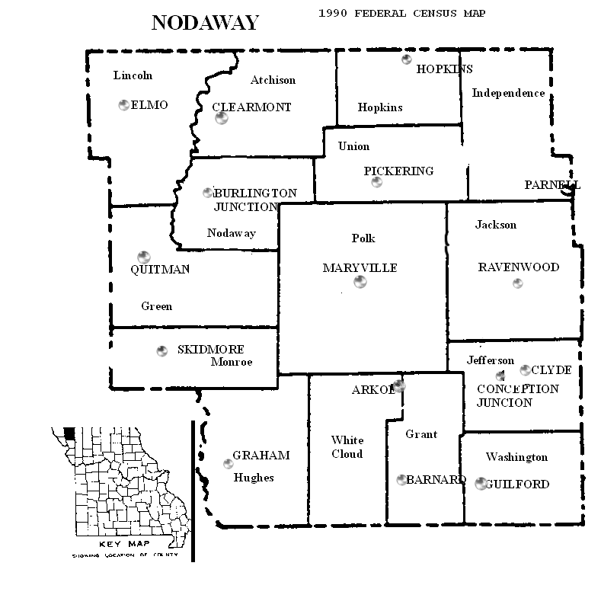
Name: _________________________________ Date: ______________

Answer the following questions based on the Nodaway County Celebrations lecture.

- What was the circuit Chautauqua?

- When was the first Hopkins picnic held?

- What was the prize for one ticket holder at the 1936 Pickering Horse Show?

- Why did the Emancipation Celebration end in 1919?

- Why did the first Nodaway County fair begin in 1871?

- When did the Nodaway County fair become the annual event we see today?

- What horse show circuit is the Pickering Horse Show part of?

- What was read every year at the Emancipation Celebration?

- Why did the Circuit Chautauqua in Nodaway County end in 1929?

- What celebration has been an annual event since 1992, making it the longest celebration in Nodaway County?

Name: Answer Key Date:

Answer the following questions based on the Nodaway County Celebrations lecture.

- What was the circuit Chautauqua?
The Circuit Chautauqua was a form of the original Chautauqua that was started by talent agents seeking a profit. It travelled over the United States so that more people could attend.

- When was the first Hopkins picnic held?
July 4, 1882; 1882

- What was the prize for one ticket holder at the 1936 Pickering Horse Show?
A Ford car

- Why did the Emancipation Celebration end in 1919?
The committee did not have enough funds to pay off their debt.

- Why did the first Nodaway County fair begin in 1871?
As a way for the county to show off their quality livestock.

- When did the Nodaway County fair become the annual event we see today?
1979

- What horse show circuit is the Pickering Horse Show part of?
Four River’s Horse Show Circuit

- What was read every year at the Emancipation Celebration?
Emancipation Proclamation

- Why did the Circuit Chautauqua in Nodaway County end in 1929?
Because of the expansion and availability of cars and radios that allowed for the same information to be spread faster

- What celebration has been an annual event since 1992, making it the longest celebration in Nodaway County?
The Hopkins Picnic

